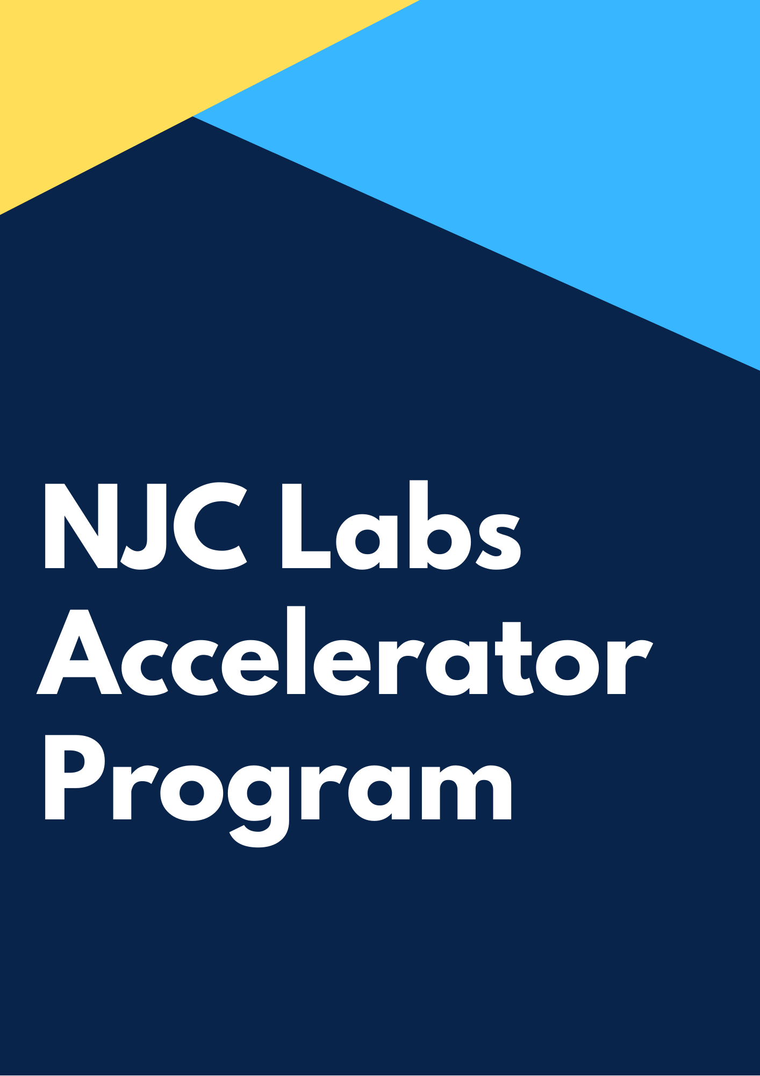

Introduction

Welcome to NJC Labs Architecture Accelerator program. This is one of the carefully crafted unique training programs that enables you to become an Integration Architect quickly, without compromising on the core skills that are crucial to embark on a successful career in the software industry.

This training program is an outcome of years of expertise in enabling senior software engineers of our clients and partners to overcome technological challenges, by rapidly ramping up the required skills, so that they are enabled to drive software projects from inception to production, delivery and maintenance, independently.

NJC Labs Architect accelerator program is designed to enable a senior developer or architect to master the integration and enterprise architecture concepts that are required to kick start on a project from day one and deliver customer success.

A Detailed description of the program is described below. The entry to Architecture Accelerator program is based on a preliminary assessment, which would be shared along with brochure.

We want you to complete this assessment to assign you to a custom accelerator program level catering to your needs.

An Overview of Accelerator Program

Integration & Enterprise Architecture is a broad field both in depth and breadth. The core skills required to be successful in each of these domains are different. For instance, to be successful an Integration Architect needs to have a broader understanding of software systems, architectures, protocols, data structures and patterns to connect systems and applications, Where as an enterprise architect will make recommendations for adjusting policies and projects to achieve target business outcomes that capitalize on relevant business disruptions. EA is used to steer decision making toward the evolution of the future state architecture.

Our preliminary skill assessments are aligned to identifying the basic skills needed to participate in these architecture accelerated programs.

Based on your technical background, experience, knowledge and expertise, we may be able to guide you through the relevant skills that you need to pick up to be successful working on enterprise software projects.

Different modules of the accelerator program will help you deliver enterprise integration projects successfully. Through each module we want you to be a master in the technology and concepts so that you can deliver projects.

Through every module we will introduce you to a concept and then the candidate will perform an exercise to implement the concept. This will be reviewed by the mentor of the program to see the quality of the output.



Module 1: Architecture

Introduction - whats my-trains project
This is an IP (Intellectual Property) project of NJC to alert subscribers of the train service to notify any delays in train service. This project uses the web services provided by a train service provider and uses the delay notifications through APIs or web services. my-trains project will use this information to identify delays and send notifications to customers subscribed for alerts. Refer the use case document to know more about the details.

Architecture Concepts

Enterprise Architecture
Long term strategy and vision of the organisation is achieved using enterprise architecture. To achieve this vision, enterprise architects identify multiple IT projects for next few years. MuleSoft proposes to use API Led connectivity architecture to build an application network, which is the state of enterprise architecture of an organization.

TOGAF / Zachman / 4+1 Viewpoint

API Led Connectivity / Application Network

Integration Architectures
Long term strategy and vision of the organisation is achieved using enterprise architecture. This will usually contain multiple projects, like file transfer, ETL based, batch etc. This project specific architecture is Integration Architecture.

SOA

EDA

ETL

Delivery Approach

Catalyst Program
Catalyst program is a unique delivery method proposed by MuleSoft to make sure customer projects are successful. There are 3 focus areas in the catalyst program: Business Outcomes, Technology Delivery and Organizational Enablement.

Diagramming Tools

Archimate
Enterprise architect’s diagramming tool

UML
Use case specific diagramming mostly

FMC
High level / Big picture / context view diagram

Exercise

Requirement Analysis
Go through the requirements and come up with uses stories of the my trains project

Diagramming - Use case
Create a use case diagram to represent different use cases my trains project

Diagramming - Sequence Diagram - UML
Create a sequence diagram to represent one of the use cases of my trains project

API Led Connectivity Architecture - Archimate
Create an API led connectivity architecture diagram for the use cases of my trains project and use archimate to draw the diagram

Resources

Links
Go through the requirements and come up with uses stories of the my trains project

Module 2: Design Center

RESTFul APIs vs Non RESTFul APIs

RAML

Definition

OAS (Swagger)

Definition

GraphQL
facebook story and advantage of GraphQL. It reduces the number of calls and improves user experience.

RPC
Slack API to show what's RPC API, RPC uses header parameters to add operation names. Used in process centric APIs

SOAP
Demonstrate a WSDL file

Richardson’s Maturity Model and Hypermedia
Shows the different levels of maturity of APIs starting from Level 0 to Level 3 which uses hypermedia.

Visual editor & Design Center
Demonstrate the use of Visual Editor to design APIs and how it can be edited in Text Editor

API Fragments

Data Type

Traits

Library

Example

Data modelling

EDM/CDM
Discuss about enterprise wide data model or common / canonical data model. This is a time taking process to define a data model across enterprise. if there is enterprise data model which is successful then use it otherwise go for bounded context

Bounded Context
Define what's Bounded Contexts. Identify a domain and draw a boundary to define a data model. You could start with business domain or subdomain or even a project. At the worst case every API could have its own data model. You also need to look at what’s power relationships.

Mirror a Backend System
You could define a data model mirroring a back end system. This could be done if there are no enterprise data models or bounded context data models.

Exercise

Data modelling - Bounded Context Data modelling
Create a bounded context based data model for my trains project

RAML
Create a RAML based API specification using data type, library for a API in my trains project

XSD
Create a xsd for input string and output string data type.

SOAP
Identify the sections of a wsdl file and create a new wsdl for helloWorld Soap API using the XSD of above exercise

Module 3: Exchange

Connector

Connector Types:

Community

Premium

Certified

Select

Custom Connector

Common Connectors

HTTP

DB

SFTP/FTP/FILE

Scheduler

REST Connector

Differences in features when you compare with HTTP

Exercise

Custom Connector
Create a simple custom connector using Mule SDK

REST Connector
Consume a REST connector in anypoint studio for the already published API in exchange and compare the differences of features from http connector.

Module 4: Developer Portal

Developer Portal

API Notebook

New Pages

Request for access

Share Resources to public portal

External Access

Deprecate a version of API

API Community Manager

Exercise

API to public portal
Share an API published in exchange to a public portal and use the API console to invoke the API deployed in the sandbox instance.

API Notebook

Create a page in one of the APIs published in exchange and add API Notebook entry to call another API from it and display the results.

Anonymous user access
Describe the process of how anonymous users access APIs deployed in public portals.

Module 5: Build Mule Application

Mule Projects & Domain Projects
Mule Project:
Mule project is a MuleSoft project which have all the dependencies defined in itself, it doesn’t share its resources or use shared resources.

Domain Project:
Mule supports the ability to define selected connectors as common resources and expose them to all applications deployed under a same domain. These resources are known as shared resources, to host these you must create a Mule Domain Project and then reference it on each of the projects that are meant to use the elements in it.

Use: In simple words, we can say Mule Domain Project is implemented to configure the resources that are shared among other applications.

Note: One Mule application can be associated to one domain only and Domain Project is only applicable for On-Premises project.

Let us create one Mule Domain Project, follow below steps to create demo mule domain project:

1. Go to File → New → Mule Domain Project.
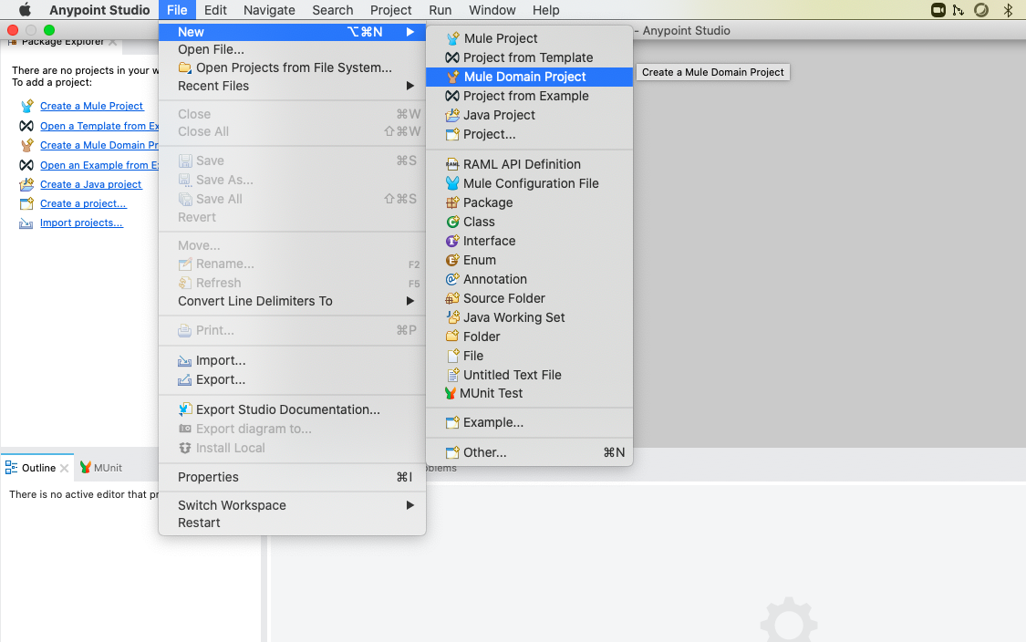

2. After clicking on Mule Domain Project, below pop-up will appear where you need to give your project name, I have give demoDomain as my project name.
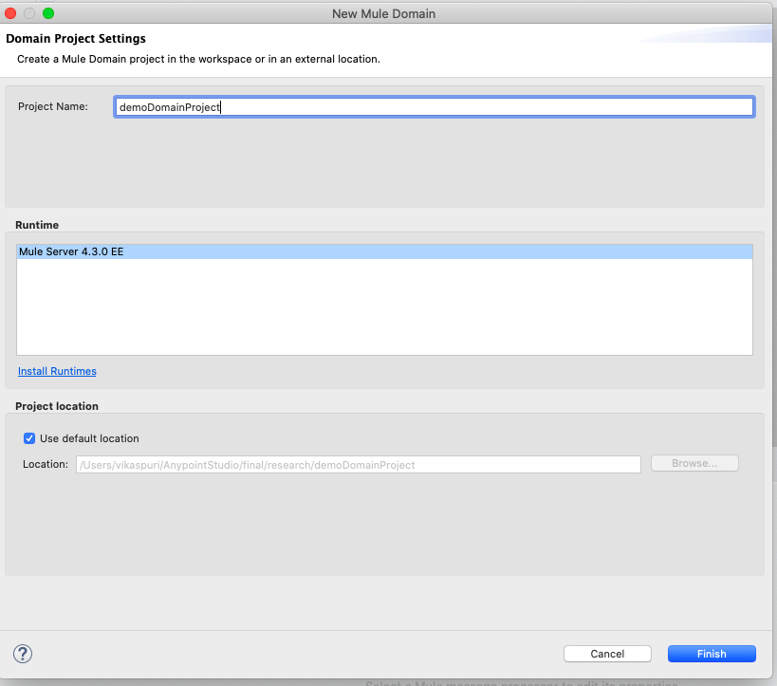

3. After this we can configure resources which we want to be shared among other project, if some connectors not available then that we can import from exchange.
Like in this we want our HTTP connector to act as a shared resource and it is not available, so what we need to do is to import HTTP connector from exchange. For that click on Manage Module highlighted in black as below:
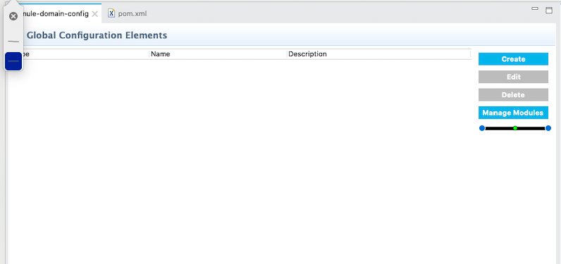

After that below pop-up will appear:
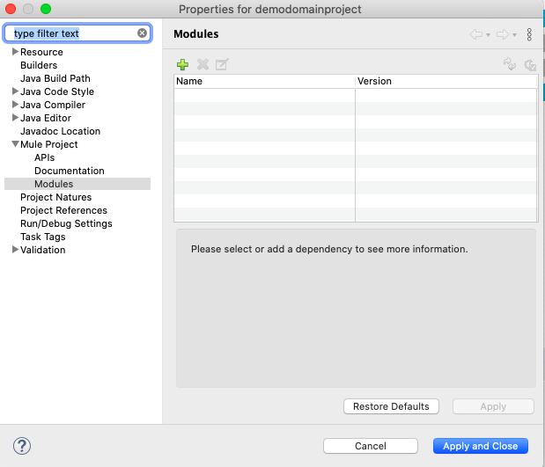

In the above pop-up, click on the “+” icon on the right panel, then below screen will appear:
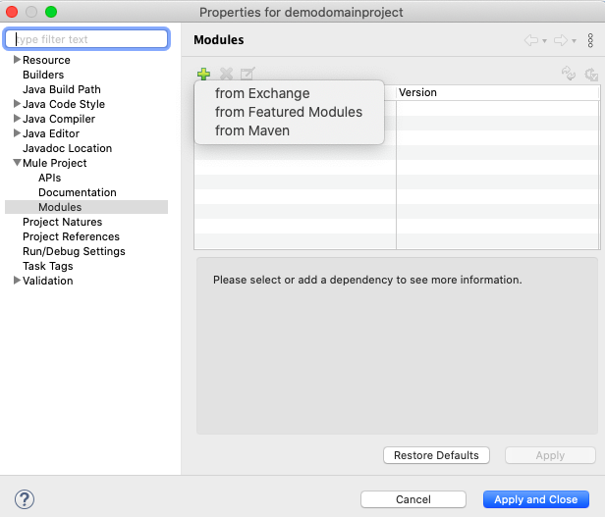
Click on the “from Exchange”, then the search screen will appear as shown below, in this what connector you want to share you can search for that like in our example we are importing HTTP connector.
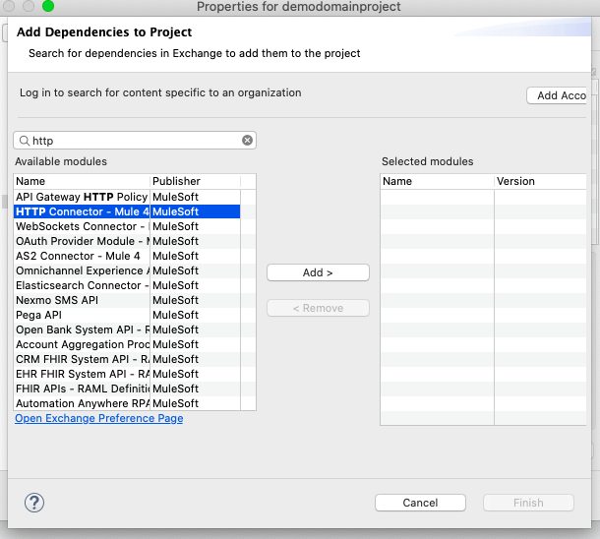
After clicking on module, just click ADD > button, and you will be able to see your selected module on the right panel. After that you can click on Finish.

4. Now our module is imported, we are good to go for our HTTP listener configuration which we need to share. Click Create button as shown in the below screen shot:

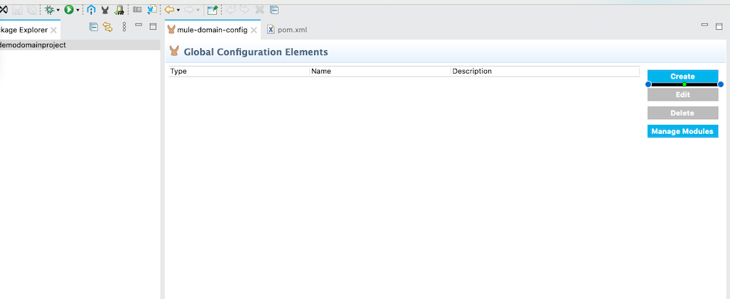

After clicking on Create, in the search box just type HTTP, then there will come matching options, and for now we will select HTTP Listener config as shown below:
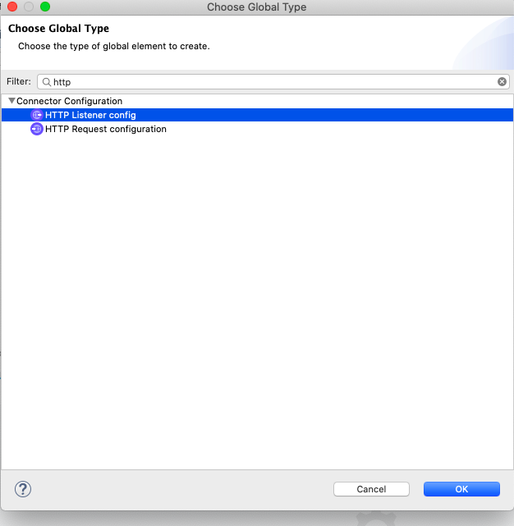

Following pop-up will appear where you can configure, by default configuration will be there which I am using as it is:
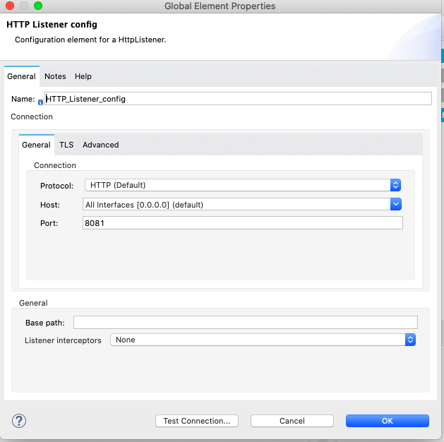

5. Now our shared resource which HTTP Listener Configuration is created, this is our domain project. Now we will create Mule project which will refer to this shared resource. In order to create Mule project, go to File → New → Mule Project as shown below:
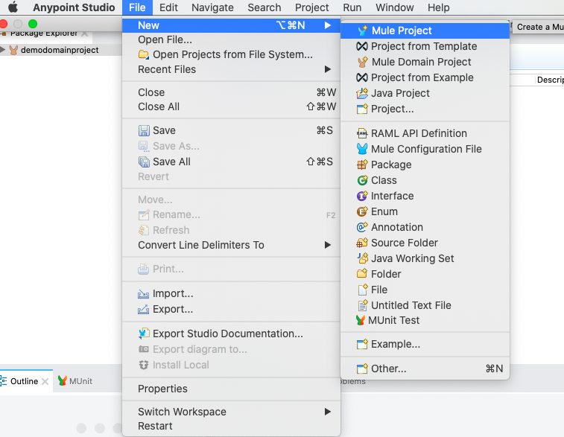

Give your project name, here I gave subDomain1 as my Mule project name.
Then do right click on Project and go to properties, then click on Mule Project on left panel as shown below and on the right side in Domain section you can select your domain project from where you want to consume shared resource, here I have selected “demodomainproject”.
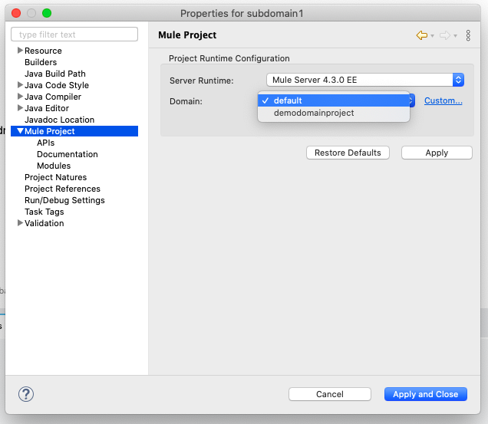

Notice now on your project, it is referring to domain project as shown below :

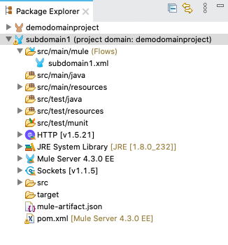

6. Now I have just dragged HTTP Listener component from the Mule Palette, there in configuration part it is showing “HTTP Listener Configuration” which we have created in domain project not here, so we are using that shared resource.
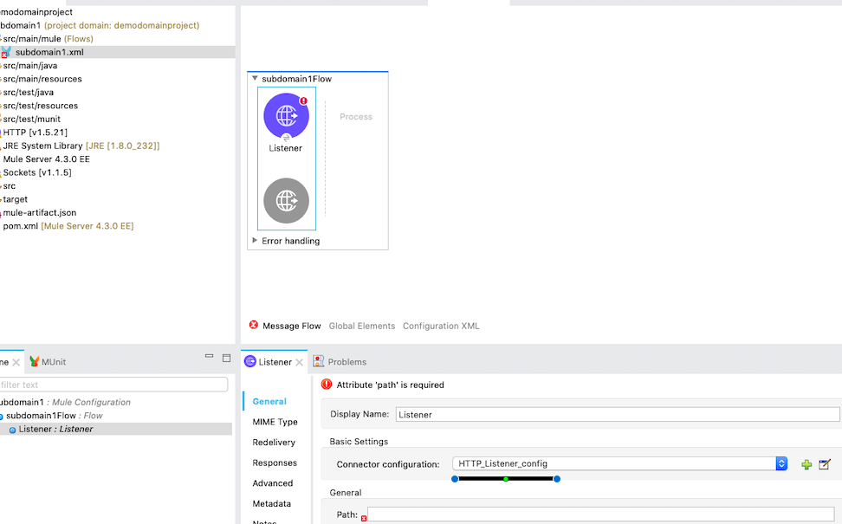

Now we are done with sample Mule Project, in order to test I will write Set- Payload and then will check whether its deployed or not.
Final testing flow will look like:
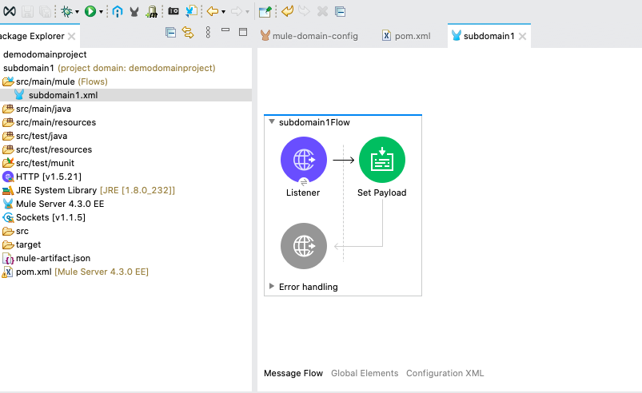

When we will run the server, your sub-domain and domain project will be deployed as shown below:
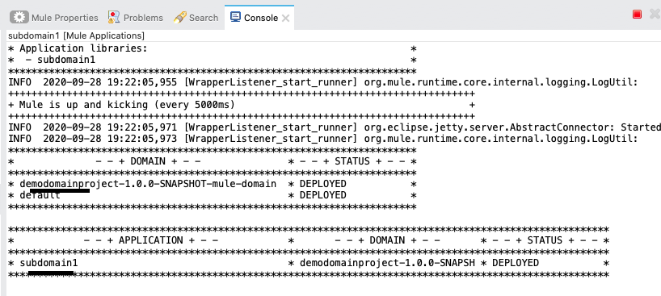

Deploying Domain Project in Standalone Server:
To deploy our project, we need to have executable Jar that we can either get through maven command or with the help of export in AnyPoint Studio.

Here we will get the executable JAR through AnyPoint Studio.

Right-click on the Domain project (“demodomainproject”) -> Export -> Mule -> AnyPoint Studio Project to Mule Deployable Archive (includes Studio metadata), choose a path, and click Finish.

Also create the Jar for subDomain1 project following the same steps for demodomainproject.

Download Mule standalone runtime: https://www.mulesoft.com/lp/dl/mule- esb-enterprise

After download extract this, then copy the “demodomainproject JAR“ and save it inside domain folder in mule standalone folder, in the same way copy subDomain1 JAR and copy that in app folder.

Go to the “bin” folder and click on the “mule” batch file, your server will start and you are done with deployment on your standalone server.

References:
https://dzone.com/articles/mule-domain-project-and-deploying-domain- project

Naming Conventions
In the application, there can be multiple developers and they may have different way to name file like one can muleproject.xml, another muleProject.xml, other mule-project.xml. So this seems to be quite weird, so companies have their naming and coding standards which every one needs to follow. We as NJC also have some standards.
Following is the snippet of the naming conventions:
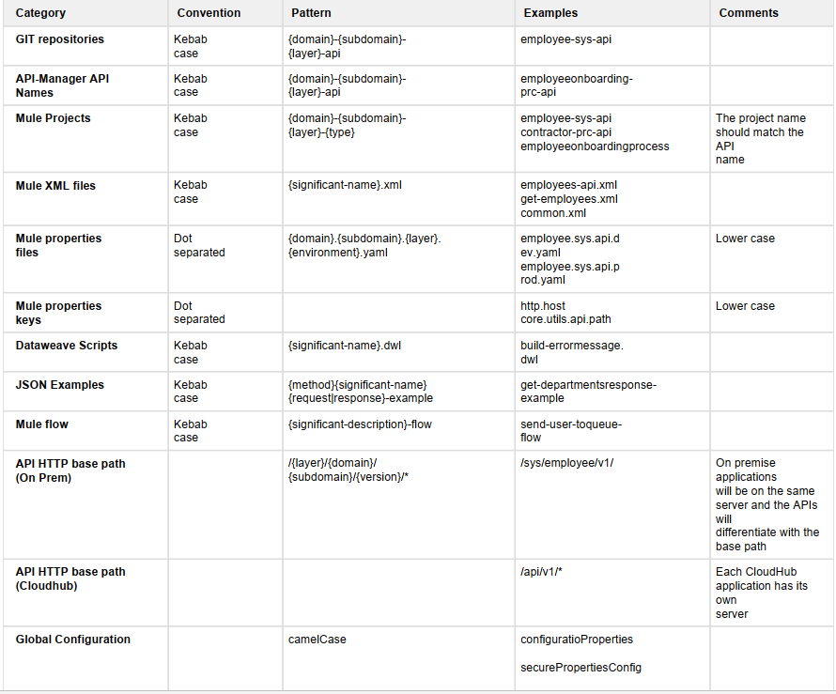

Logging
Logging helps you to monitor and troubleshoot your application and server.
If you are running you application in your local machine, then you can see the logs in your console but debugging in the production doesn’t seems to be same. So there we can use Logging. We need to log in such a way, so that no important information is lost which is desired to troubleshoot application whenever any issue comes. There are many ways to log some are log4j, slf4j, JSON Logger. Mule internally use slf4j logging.

We can log message Synchronously as well as Asynchronously.

Synchronous Logging:

The execution of flow will halt until logger logs the message. Same thread as of processing will be used.

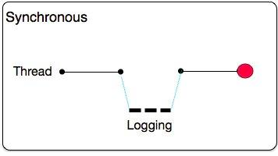

Asynchronous Logging:
By default Mule supports this logging depending on the log level like info, debug. In this separate thread will be created for logging which is just like fire and forget and the flow will continue.

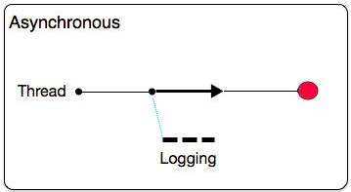

Log4j
When you create mule project, then log4j2.xml will be create in src/main/resources folder as shown below:
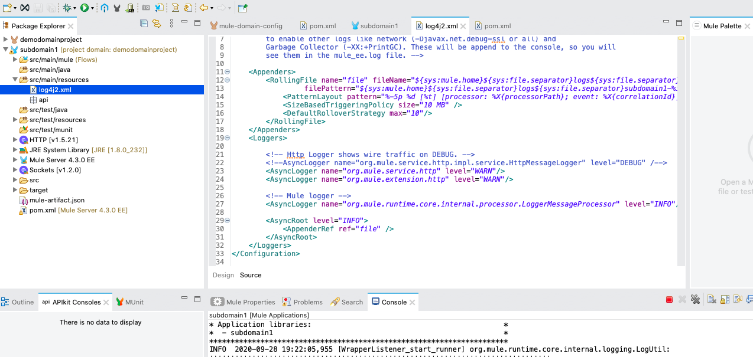

The <RollingFile> directive is used when we want to send log data to the filesystem of the VM.

In the similar way, we can also send log data to CloudHub using <Log4J2CloudhubLogAppender>. Following is the snippet for the same:
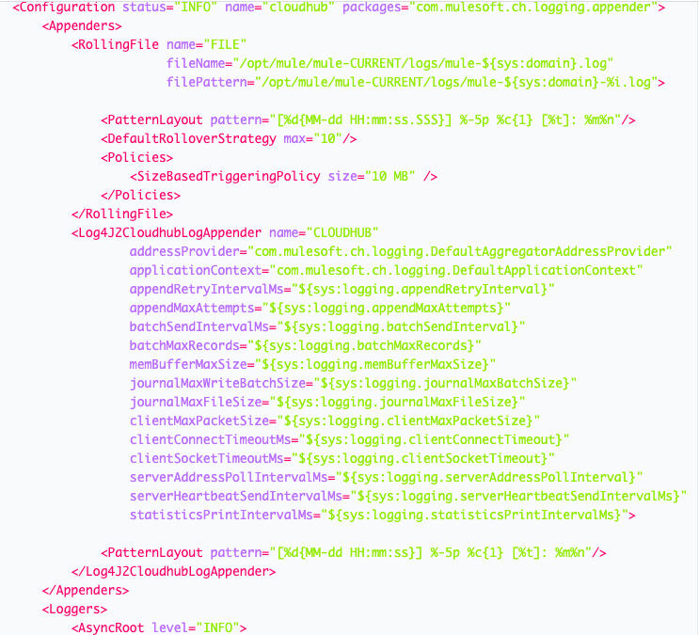

Correlation Id
CorrelationId could be of use to uniquely identify a single request end to end from client app to the downstream systems or apis.

For synchronous requests, its easy to track the request but for asynchronous request or if we are using different micro-services, its not easy to track that which response is for which request.

For graphical explanation, see the below snippet:

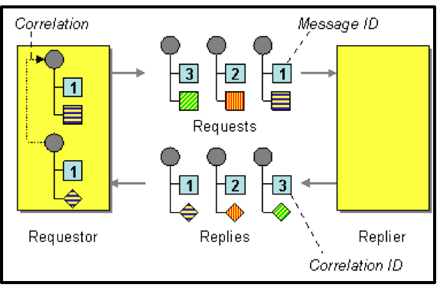

In the above snippet, you can see we are sending requests 3 after that 2, then finally 1 but we are getting response asynchronously, so now with correlation Id like for above 3 we can know its request is also 3, and same with others.

Correlation is part of event context if it is present then it will take that, otherwise will randomly generate the correlation ID. When a HTTP request is received, it will check for “X- Correlation-Id" header
- If "X-Correlation-Id" header is present, HTTP connector uses this as the Correlation Id.
- If "X-Correlation-Id" header is NOT present, a Correlation Id is randomly generated.

For incoming HTTP request:
In order to set a custom Correlation Id, the client invoking the HTTP request must set "X-Correlation-Id" header. This will ensure that the Mule Flow uses this Correlation- Id.

For Outgoing HTTP request:
You can also propagate the existing Correlation Id to downstream APIs. By default, all outgoing HTTP Requests send "X-Correlation-Id" header. However, you can choose to set a different value to "X-Correlation-Id" header or set "Send Correlation Id" to NEVER.

References:
https://apisero.com/a-bit-about-correlation-id/

Externalization of logs
Instead of writing logs to file on our own servers, we can externalize our logs and can write our logs to the centralized logging system like Splunk, Elk etc. This may gives you various advantage like you can easily analysis, reporting and above that it is secure and keep data for long time.

Also we can say that if we have simple logging system, then logs are very complex and difficult to understand. It is also unstructured format and not suitable for making analysis and visualization.

In order to solve all the above issues, some tools are available in which we can easily analyse the data, graphically view .

Splunk is a centralized logging tool which is used to search, analyze and visualize the data.
In order to have better understanding lets start with integration of Splunk with MuleSoft and we will use JSON Logger so that we can have loggers in JSON format which will be easy to understand.

JSON Logger Integration:
- Refer to the mentioned URL to add JSON Logger to the AnyPoint Exchange
https://blogs.mulesoft.com/dev/anypoint-platform-dev/json-logging-mule-4/
- Add the JSON Logger Module to your project from Exchange.

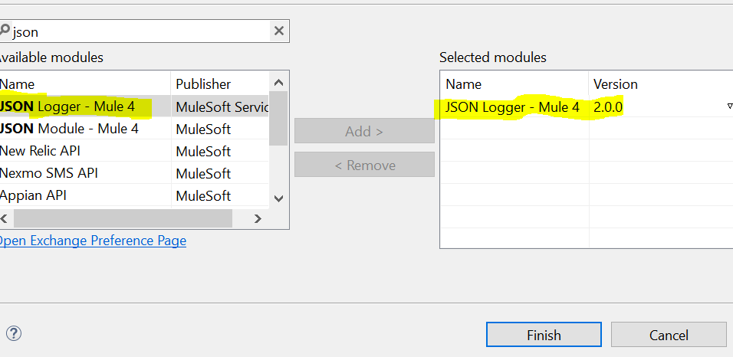

- Now you can find JSON Logger in your mule palette and it will look like as shown in below snippet.

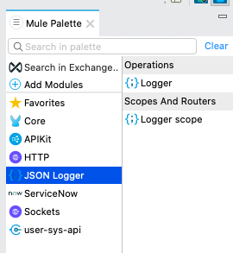

- Drag the Logger component to your flow, and then click on Logger component it will be like as shown below:

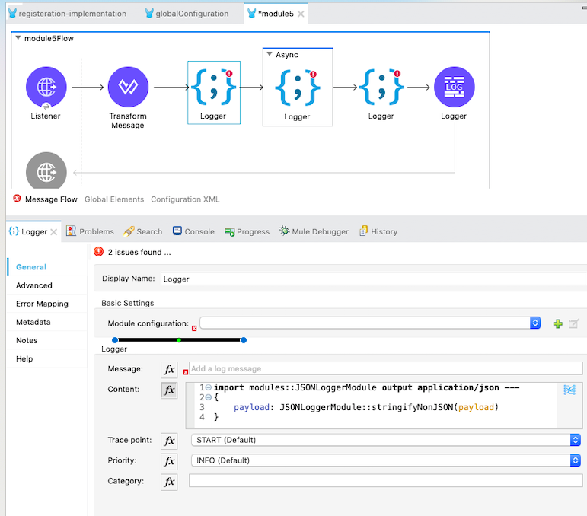

- Notice that in above snippet “Module Configuration” is empty, so you can create new Configuration by clicking “+” button. Below is the snippet of screen which will appear

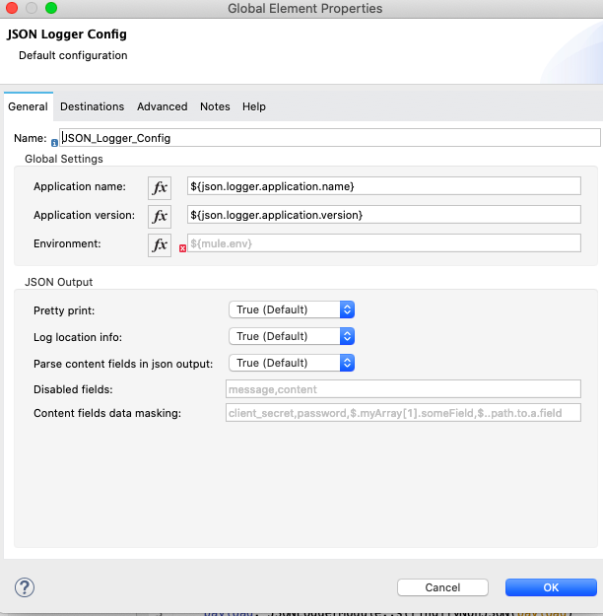

The details of Application name, Application version and Environment you need to fill.

- Now following screen will appear, here in message you need to write what you want to log.

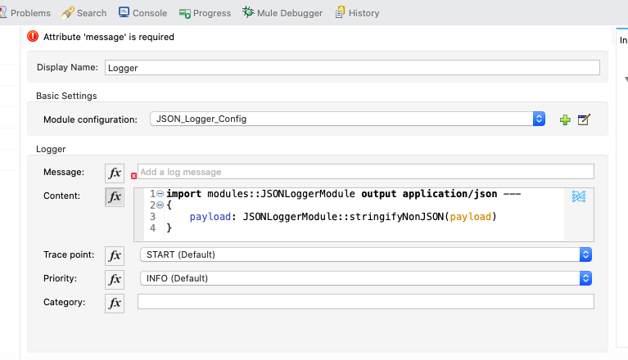

Now we are done with JSON Logging, let us now configure Splunk.

Follow the steps mentioned in “ https://dzone.com/articles/recipe-to-implement-splunk- enterprise-on-premise-f ” to configure Splunk

Versioning

Semantic Versioning
Semantic Versioning is a universal standard which is followed to do versioning of software system. It is having four components: Major release number, minor release number, patch release number and an optional service pack number.
Format: MAJOR.MINOR.PATCH

Major:
Whenever we made enhancements or changes in already existing API’s or new API’s in such a way that it will break the previous API’s functionality. Like in Mule Major version changes from 3 to 4 because there are several functionalities introduced which were not compatible or not supported and break the functionality. Like Exception strategies totally changed.

Minor:
We need to change Minor number, when we introduce enhancement which are backward compatible.

Patch:
As soon as we fix bugs and do deployment this version we need to increment.

Important Points to consider while doing versioning:
- Major, Minor and Patch should be non-negative, must not contains leading zeros and should be incremented. Like 1.10.0 → 1.11.0
- Once version is published content should not change, then new version will be published.

If you are still developing your API’s then you can start with 0.1.0, and so on. Once application gets finalized and ready for production for first release, then must be 1.0.0.

Reference: https://semver.org/

Control Flows

Choice :The Choice router dynamically routes messages through a flow according to a set of DataWeave expressions that evaluate message content.

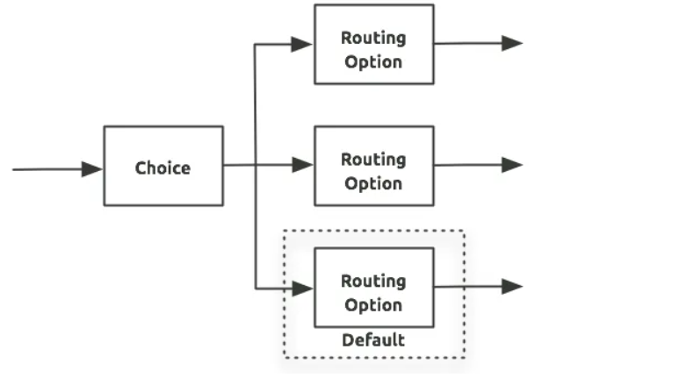
https://www.sfdcpanther.com/choice-and-scattergather-router-foreach-in-mulesoft/

First Successful:The First Successful router iterates through a list of configured processing routes until one of the routes executes successfully. If any processing route fails execution (throws an error), the router executes the next configured route.

If none of the configured routes execute successfully, the First Successful router throws an error.

Round Robin

Scatter Gather:The routing message processor Scatter-Gather sends a request message to multiple targets concurrently. It collects the responses from all routes, and aggregates them into a single message.
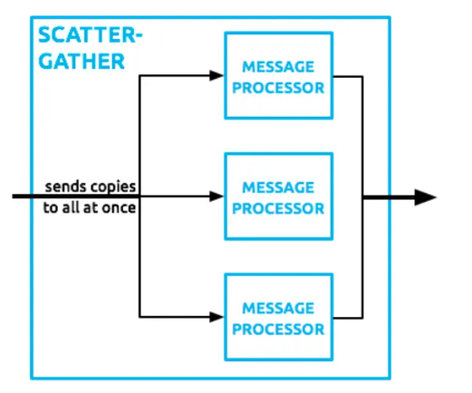

Dataweave
https://docs.mulesoft.com/mule-runtime/4.3/dataweave-quickstart

Exception handling

Exercise

Mule Projects & Domain project
Create a domain project and deploy them in a standalone server so that multiple applications can use the shared configs like http listner from domain project.

Exception Handling
Use error mapping, raise error, error continue & error propagate to implement exception handling in various use cases of my trains project.

Advanced Dataweave
Use the below scenario and implement dataweave to do the data transformation from source to destination.

The following is the JSON payload which is an object of ArrayList grouped based on User_id and each object has the duplicate/repetitive occurrence of the following properties:user_id, subscription_id, from_time, to_time, and name against each month.
{
"1": [
{
"user_id": "1",
"from_time": "07:00",
"to_time": "08:00",
"Month": 1,
"delay_1": 10,
"delay_2": 3,
"name": "Aaron Scheepens",
"subscription_id": 1
},
{
"user_id": "1",
"from_time": "07:00",
"to_time": "08:00",
"Month": 2,
"delay_1": 5,
"delay_2": 6,
"delay_3": 1,
"name": "Aaron Scheepens",
"subscription_id": 1
},
{
"user_id": "1",
"from_time": "07:00",
"to_time": "08:00",
"Month": 3,
"delay_1": 1,
"name": "Aaron Scheepens",
"subscription_id": 1
},
{
"user_id": "1",
"from_time": "07:00",
"to_time": "08:00",
"Month": 4,
"delay_1": 1,
"name": "Aaron Scheepens",
"subscription_id": 1
},
{
"user_id": "1",
"from_time": "07:00",
"to_time": "08:00",
"Month": 5,
"delay_1": 1,
"name": "Aaron Scheepens",
"subscription_id": 1
},
{
"user_id": "1",
"from_time": "07:00",
"to_time": "08:00",
"Month": 6,
"delay_1": 1,
"name": "Aaron Scheepens",
"subscription_id": 1
},
{
"user_id": "1",
"from_time": "07:00",
"to_time": "08:00",
"Month": 7,
"delay_1": 1,
"name": "Aaron Scheepens",
"subscription_id": 1
},
{
"user_id": "1",
"from_time": "07:00",
"to_time": "08:00",
"Month": 8,
"delay_1": 1,
"name": "Aaron Scheepens",
"subscription_id": 1
},
{
"user_id": "1",
"from_time": "07:00",
"to_time": "08:00",
"Month": 9,
"delay_1": 1,
"name": "Aaron Scheepens",
"subscription_id": 1
},
{
"user_id": "1",
"from_time": "07:00",
"to_time": "08:00",
"Month": 10,
"delay_1": 1,
"name": "Aaron Scheepens",
"subscription_id": 1
},
{
"user_id": "1",
"from_time": "07:00",
"to_time": "08:00",
"Month": 11,
"delay_1": 1,
"name": "Aaron Scheepens",
"subscription_id": 1
},
{
"user_id": "1",
"from_time": "07:00",
"to_time": "08:00",
"Month": 12,
"delay_1": 1,
"name": "Aaron Scheepens",
"subscription_id": 1
}
],
"2": [
{
"user_id": "2",
"from_time": "07:30",
"to_time": "09:00",
"Month": 1,
"delay_1": 10,
"delay_2": 3,
"name": "Mike Sparrow",
"subscription_id": 2
},
{
"user_id": "2",
"from_time": "07:30",
"to_time": "09:00",
"Month": 2,
"delay_1": 5,
"delay_2": 6,
"delay_3": 1,
"name": "Mike Sparrow",
"subscription_id": 2
},
{
"user_id": "2",
"from_time": "07:30",
"to_time": "09:00",
"Month": 3,
"delay_1": 1,
"name": "Mike Sparrow",
"subscription_id": 2
},
{
"user_id": "2",
"from_time": "07:30",
"to_time": "09:00",
"Month": 4,
"delay_1": 1,
"name": "Mike Sparrow",
"subscription_id": 2
},
{
"user_id": "2",
"from_time": "07:30",
"to_time": "09:00",
"Month": 5,
"delay_1": 1,
"name": "Mike Sparrow",
"subscription_id": 2
},
{
"user_id": "2",
"from_time": "07:30",
"to_time": "09:00",
"Month": 6,
"delay_1": 1,
"name": "Mike Sparrow",
"subscription_id": 2
},
{
"user_id": "2",
"from_time": "07:30",
"to_time": "09:00",
"Month": 7,
"delay_1": 1,
"name": "Mike Sparrow",
"subscription_id": 2
},
{
"user_id": "2",
"from_time": "07:30",
"to_time": "09:00",
"Month": 8,
"delay_1": 1,
"name": "Mike Sparrow",
"subscription_id": 2
},
{
"user_id": "2",
"from_time": "07:30",
"to_time": "09:00",
"Month": 9,
"delay_1": 1,
"name": "Mike Sparrow",
"subscription_id": 2
},
{
"user_id": "2",
"from_time": "07:30",
"to_time": "09:00",
"Month": 10,
"delay_1": 1,
"name": "Mike Sparrow",
"subscription_id": 2
},
{
"user_id": "2",
"from_time": "07:30",
"to_time": "09:00",
"Month": 11,
"delay_1": 1,
"name": "Mike Sparrow",
"subscription_id": 2
},
{
"user_id": "2",
"from_time": "07:30",
"to_time": "09:00",
"Month": 12,
"delay_1": 1,
"name": "Mike Sparrow",
"subscription_id": 2
}
]
}

Our objective is to form an array of objects which has only one object per user
_id and the delay_(n) property against month should get prepended with <month name>_delay_(n), i.e. January_delay_1. So after the final transformation, the output should be as given below:

[
{
"user_id": "1",
"subscription_id": 1,
"name": "Aaron Scheepens",
"from_time": "07:00",
"to_time": "08:00",
"January_delay_1": 10,
"January_delay_2": 3,
"February_delay_1": 5,
"February_delay_2": 6,
"February_delay_3": 1,
"March_delay_1": 3,
"April_delay_1": 4,
"May_delay_1": 5,
"June_delay_1": 6,
"July_delay_1": 4,
"August_delay_1": 10,
"September_delay_1": 2,
"October_delay_1": 3,
"November_delay_1": 4,
"December_delay_1": 5
},
{
"user_id": "2",
"subscription_id": 2,
"name": "Mike Sparrow",
"from_time": "07:30",
"to_time": "09:00",
"January_delay_1": 10,
"January_delay_2": 3,
"February_delay_1": 5,
"February_delay_2": 6,
"February_delay_3": 1,
"March_delay_1": 3,
"April_delay_1": 4,
"May_delay_1": 5,
"June_delay_1": 6,
"July_delay_1": 4,
"August_delay_1": 10,
"September_delay_1": 2,
"October_delay_1": 3,
"November_delay_1": 4,
"December_delay_1": 5
}
]

Logging
Use a mule project to demonstrate the working of json logger and externalise with splunk, use correlationId in the logs. Display a graph in splunk to show the full end to end journey of a unique request

Versioning
Implement a mule project with the support of multiple version of APIs

Module 6: Runtime Manager

Control plane vs Runtime Plane

Deployment options

CloudHub

Hybrid

RTF

PCE

PCF

Runtime Behavior / thread pool

JVM properties

Exercise

Customer hosted deployment
setup a customer hosted cluster and deploy two applications in a cluster using runtime manager. This application should also use a domain project to share http listener.

Uber Threads
Create a simple mule application and add some delay in the processing to show the thread usage. Deploy the app in 4.2.0 and 4.3.0 version of runtime and use jvisualvm / jconsole to see the different types of threads available like CPU Light, CPU Intesive, IO Blocking, grizzly threads.

RTF setup
Setup RTF and deploy a hello world app to RTF.

Loadbalancer
Install a load balancer and configure load balancing in front of the local cluster. Http requests should be load balanced to individual nodes in round robin fashion.

Module 7: API Manager

Auto Discovery

Gatekeeper feature

Enforcing Policies

Proxy

Basic end point

Anypoint servicemesh

API Manager Policies

ClientId Enforcement

JWT Policy

Caching Policy

ip whitelisting / blacklisting

auth2 policy

CORS

Rate Limiting

Spike Control

Tokenization vs DeTokenization

API Group

Automated policies

Auth2. 0 policy

Exercise

Configure Oauth2 policy using okta
Create oauth2 policy for an experience api of my-trains project .

Configure client-id / secret policy for an api
Create clientId enforcement policy to secure APIs .

Different Auto Discovery behaviours
Auto discovery in basic end point approach is manual whereas AutoDiscovery is automatic in end point with proxy option. Demonstrate this with an example and explain how the gatekeeper feature works. Deploy the same application in hybrid and see how discovery works. Try to deploy applications with the same instance id to hybrid and cloudhub.

Custom policy
Create a custom policy and demonstrate the working of a custom policy.

Deletion & Deprecation
Identify the differences between deletion and deprecation in API Manager and Exchange

    - Configure https certificate for a proxy in API proxy
Create a API proxy and configure https for the proxy

Module 8: Anypoint security

Features

Tokenization

Masking

Encryption

Edge Policies

Exercise

Explore anypoint security policies
Write an article about the features of anypoint security

Module 9: Design patterns & integration pattern

Enterprise Integration Patterns

Scatter Gather

Enrichment

Message Based Routing

Choice Router

Transformer

Dataweave

XSLT

Scripting

Java

Object Oriented Design Patterns

Observer pattern & Iterator Pattern - backpressure

CQRS / Eventual Consistency

Reliability Pattern

Circuit Breaker

Exercise

Circuit Breaker
Implement a mule application to demonstrate Circuit Breaker scenario in synchronous use case / APIs

Reliability pattern
Implement a reliability pattern for a use case in which huge files (million records) are synchronized with salesforce. .

Backpressure
Implement a mule application to explain the use of back pressure

Module 10: Object Store & Use cases

Object Store

Persistence & Non persistence behaviour in different deployment options

State storage use cases

Caching

Watermark

Circuit Breaker

Token Storage

External systems for storing state

Exercise

Circuit Breaker implementation
Implement Circuit breaker scenario to stop processing messages from a JMS when the downstream systems like DB / API is down. Messages which are failed will be forwarded to DLQ and the system should start processing messages when the downstream systems are online. Use my trains project

Module 11: Scheduler & Use cases

Near real time processing

Scheduler

Primary Node only configuration

Exercise

Scheduler in cluster
Build an application to see how the scheduler works in the cluster..

Scheduling strategy in File Connector
Build an application to see how the scheduling strategy works in file connector

Module 12: Messaging & Use cases

Messaging / Asynchronous / Real Time Processing options

JMS

VM Queue

Anypoint MQ

Kafka

Exercise

Messaging with million messages
Implement a million messages

Module 13: Streaming & Use cases

Streaming Processing options

Types of Streaming

Connector Behaviour in streaming

Streaming in Batch

Exercise

adf
dsfasdfas

Module 14: Asynchronous & Use cases

Streaming Processing options

Types of Streaming

Connector Behaviour in streaming

Streaming in Batch

Exercise

adf
dsfasdfas

Module 15: Testing Strategies

Unit Testing

MUnit

Junit

Integration Testing

SoapUI

Postman

Rest Assured

Test Coverage

Resilience Testing

Performance Testing

Blazemeter / JMeter

Exercise

Munit Test Case
Create a Munit Test suite to perform unit testing of a use case in my trains project.

Soap UI Testing
Create a SoapUI project to place a file in a file directory and see the output of mule processing from the database.

Module 16: High Availability

High availability

Cluster

Multi Worker in CloudHub

Multiple Standalone nodes

Load balancing

Primary Nodes

Load balancing of VM Queues and Object store

Behaviour of Connectors in Load balancing

Exercise

Module 17: Reliability

Reliability

Transaction

Until Successful

Reconnection Strategies

Redelivery

Exercise

Module 18: Performance Tuning

Performance tuning

Dataweave

Connector Configuration

Component Configuration

Profiling

JvisualVM

Exercise

Module 19: Network Security

Security

Data at Rest

Encryption

Crypto Module

Data in Transit

TLS (one way / two way)

VPC

VPN

Exercise

Module 20: Application Security

Security

Data at Rest

Encryption

Crypto Module

Data in Transit

TLS (one way / two way)

VPC

VPN

Exercise

Module 21: Monitoring & Automation

Visualizer

Anypoint Monitoring

Custom Dashboard

Builtin Dashboard

Anypoint Analytics

Custom Dashboard

Chart

Reports

Runtime Manager Dashboard

Insights

Alerts

Runtime Manager

API Manager

CloudHub Connector

Exercise

